To run scripts:

1. Open script with your favorite editor
2. The following packages must be loaded: 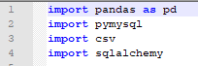
3. Open .csv in pandas and copy csv column names in a pandas DataFrame 
4. Print the first few rows to ensure there arent any NaN’s
5. Enter your username and password in the following fields. After enter the loopback address in the host variable and the name of the database created in MYSQL.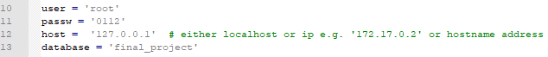
6. With each csv, ensure that the name of the current database is correct and the chosen name of the table is in the name= field surrounded by single quotes. 
7. Save and exit
8. In the bash environment, upload the py script along with the csv and run it
   1. *Python3 <PY SCRIPT NAME>.py*
9. The script will automatically create the table and populate the rows.
10. To ensure the script ran successfully, enter:
    1. mysql -u root -p –host 127.0.0.1
    2. use <DATABASE NAME>;
    3. show tables;
11. Run a simple query to ensure that it is operational.